**PROJECT TITEL: CRM application for jewel management**

**College Name: KAAMADHENU ARTS AND SCIENCE**

**College Code: bru4p**

**TEAM ID: NM2025TMID21136**

**TEAM MEMBERS: 4**

**Team Leader Name: PUNITHAVATHI S**

**Email: punithavathi.cs23@kascsathy.ac.in**

**Team Member: PRIYADHARSHINI S**

**Email: priyadharshini.cs23@kascsathy.ac.in**

**Team Member: NIVETHA T**

**Email: nivetha.cs23@kascsathy.ac.in**

**Team Member: MONILSON K**

**Email: monilson.cs23@kascsathy.ac.in**

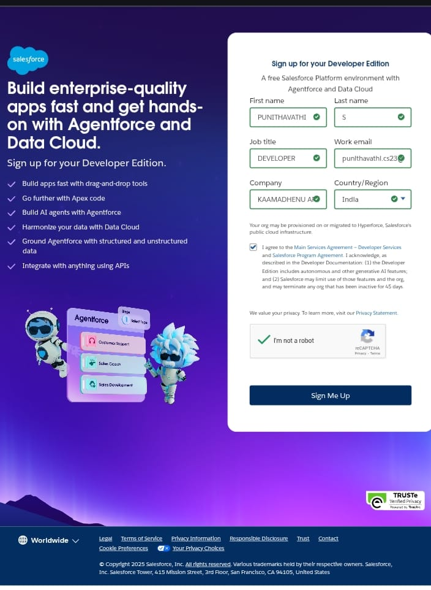

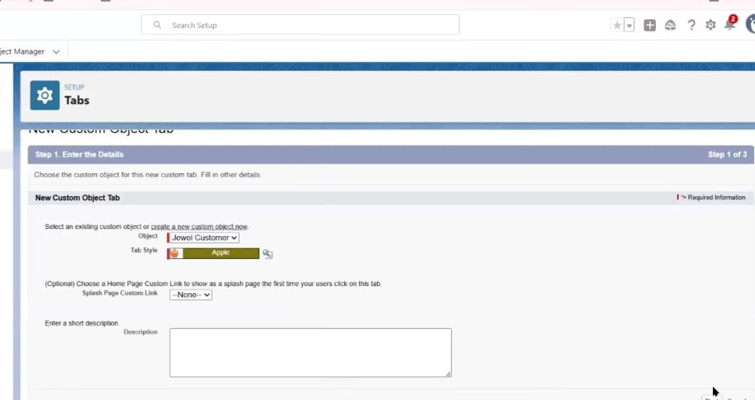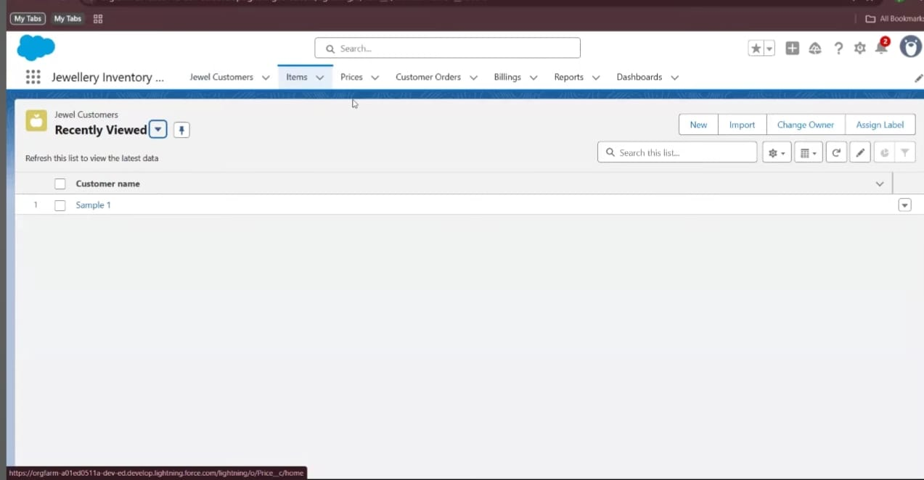

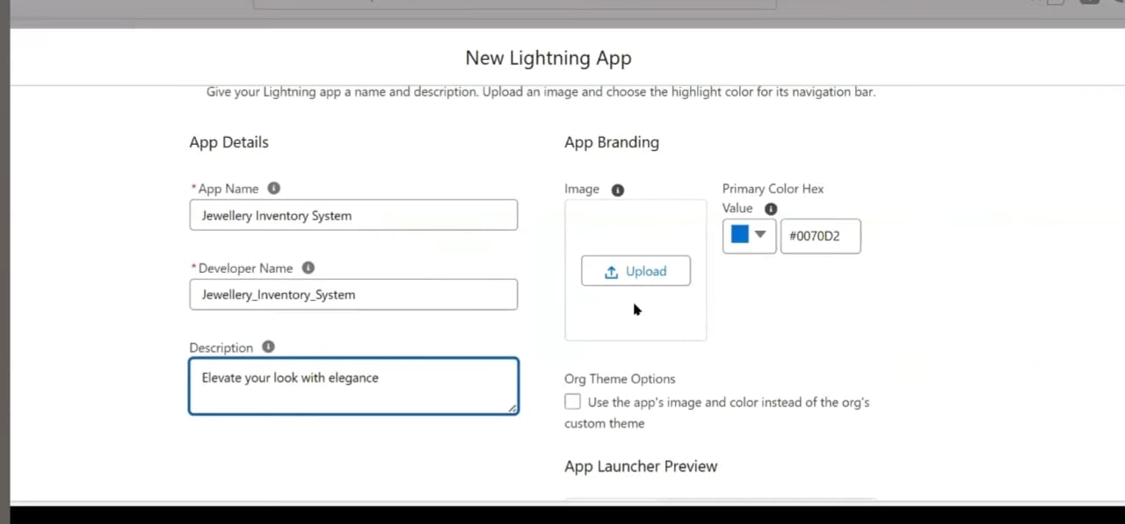

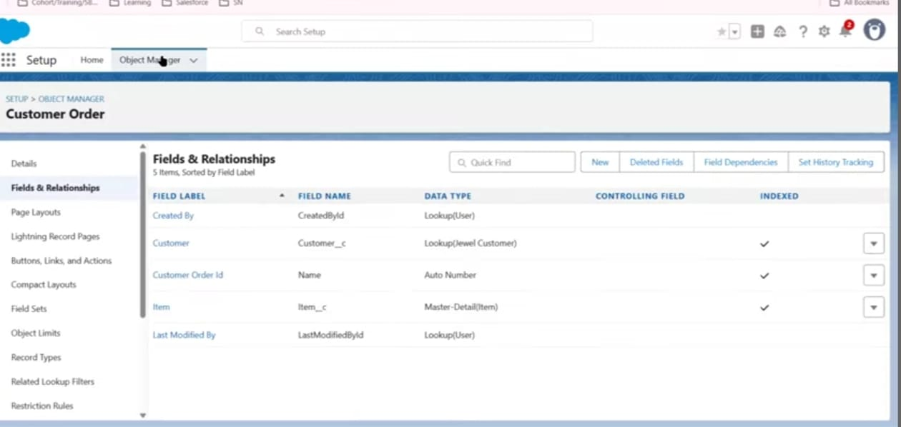

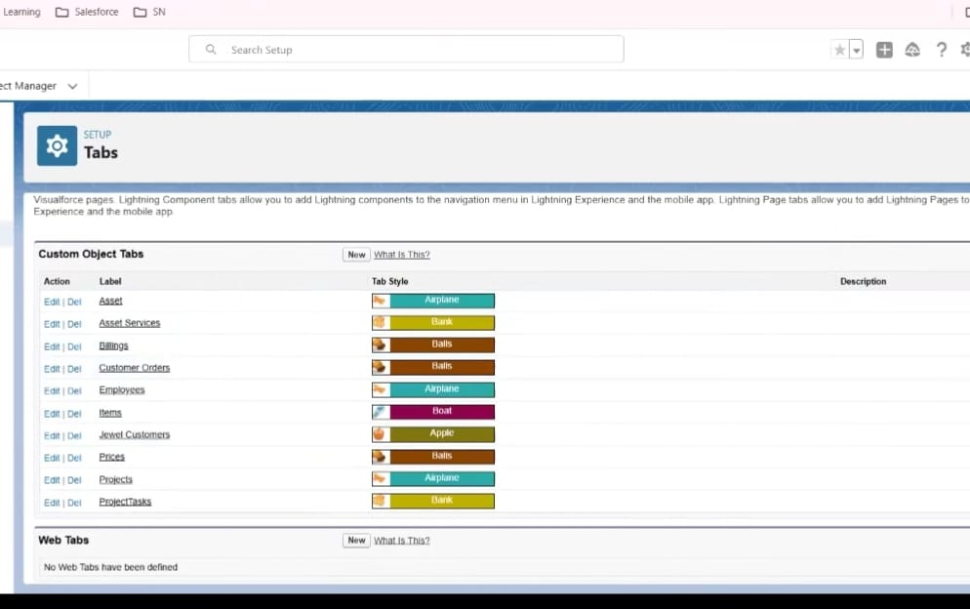

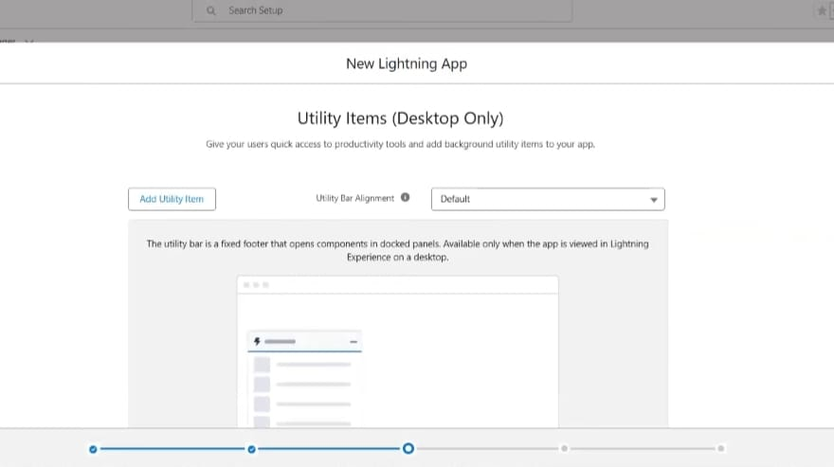

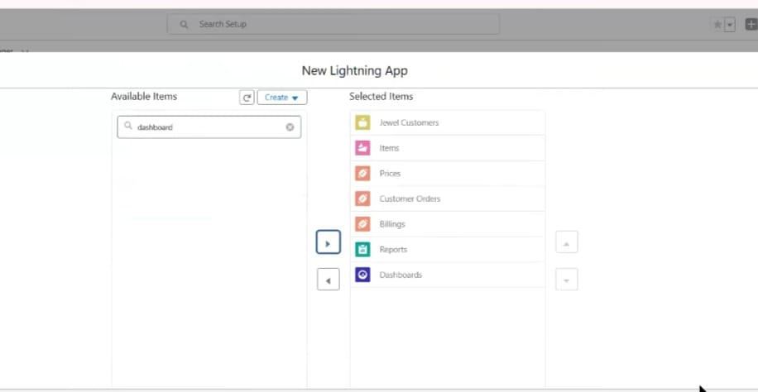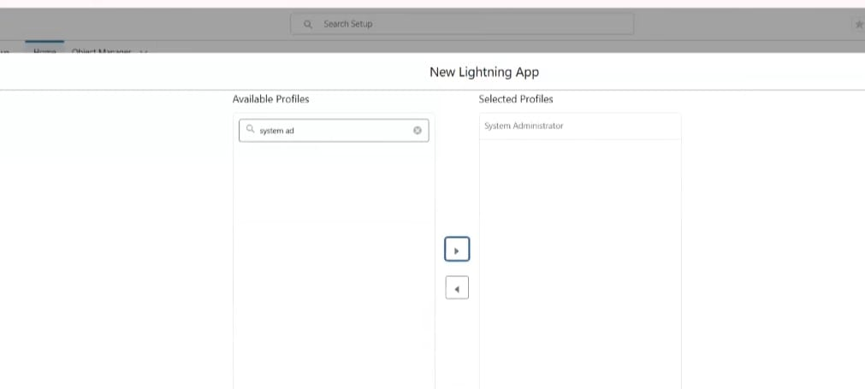

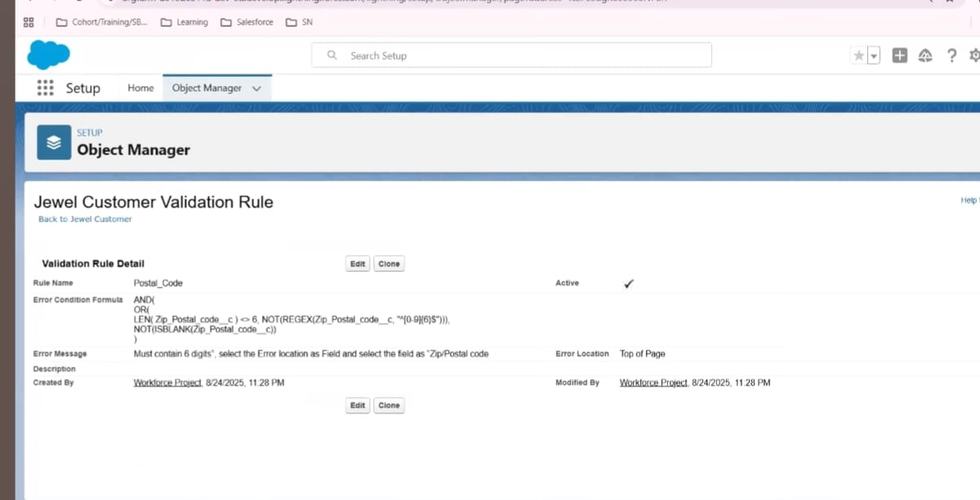

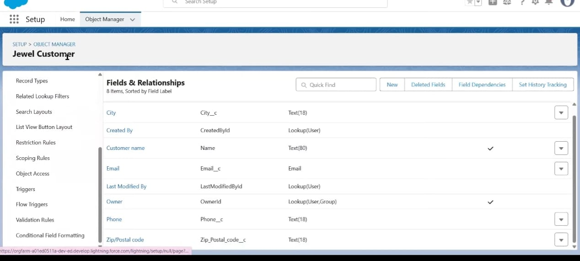

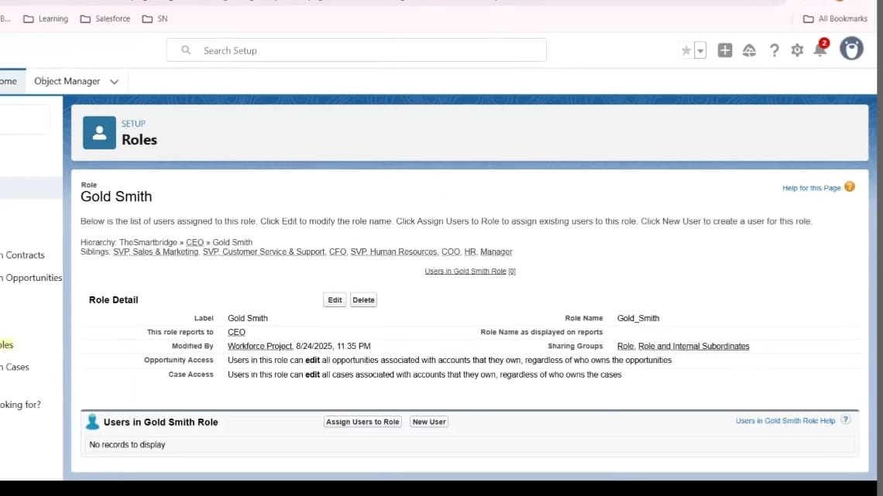

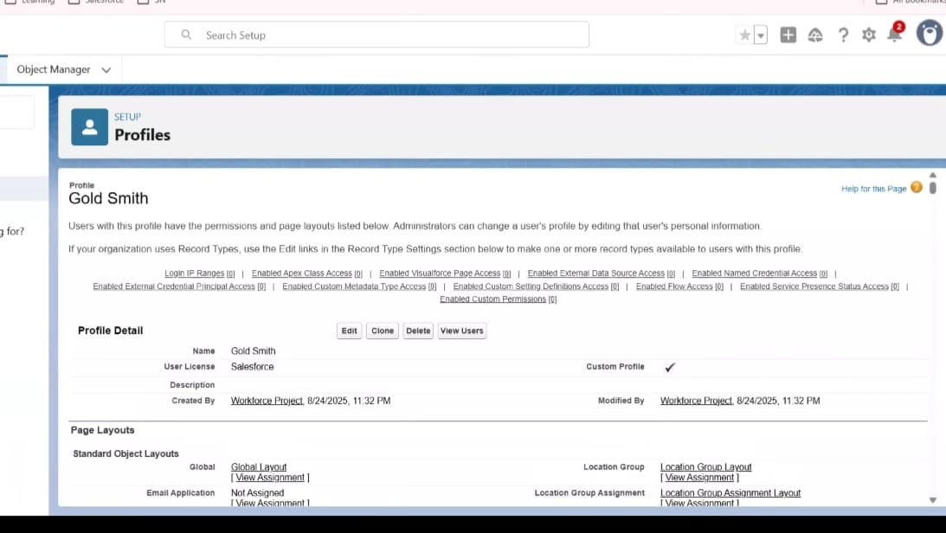

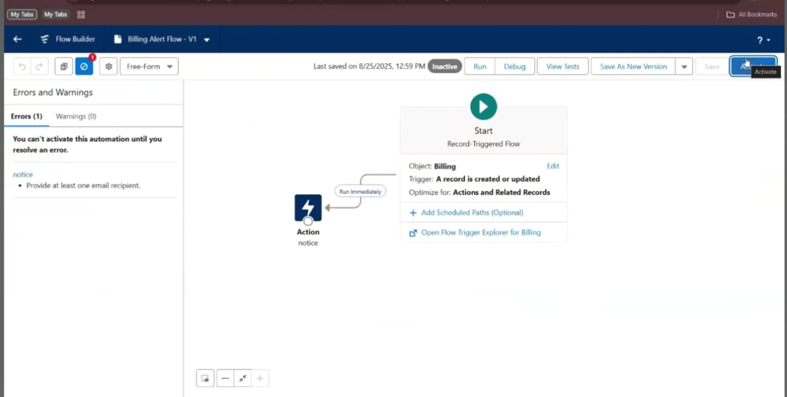



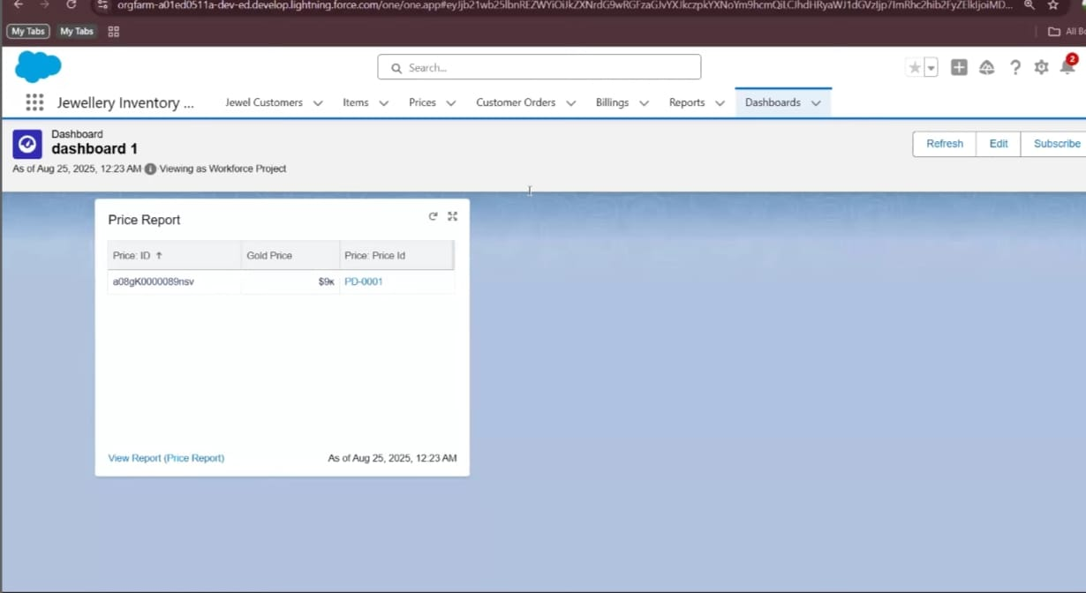

public class UpdatePaidAmountTriggerHandler {

    public static void handleBeforeInsert(List<Billing__c> newBillings) {

        for (Billing__c billing : newBillings) {

            billing.Paid_Amount__c = billing.Paying_Amount__c;

        }

    }

    public static void handleBeforeUpdate(Map<Id, Billing__c> oldBillingsMap, List<Billing__c> updatedBillings) {

        for (Billing__c billing : updatedBillings) {

            Billing__c oldBilling = oldBillingsMap.get(billing.Id);

            Decimal oldPaidAmount = oldBilling.Paid_Amount__c;

            billing.Paid_Amount__c = oldPaidAmount + billing.Paying_Amount__c;

        }

    }

}

trigger UpdatePaidAmountTrigger on Billing__c (before insert, before update) {

    if (Trigger.isInsert) {

        UpdatePaidAmountTriggerHandler.handleBeforeInsert(Trigger.new);

    } else if (Trigger.isUpdate) {

        UpdatePaidAmountTriggerHandler.handleBeforeUpdate(Trigger.oldMap, Trigger.new);

    }

}